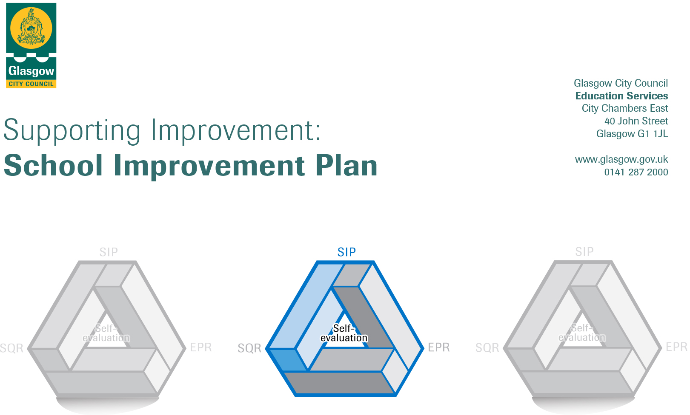

Session: 2023-24

Establishment |  | Elie Street Nursery
Head of Establishment |  | Michelle Smith
Area/Local Improvement Group |  | NW LIG 2
Head of Service |  | Jean Miller
Area Education Officer/  Quality Improvement Officer |  | Liz Kerr

CONTENTS
1. Vision, Values and Aims
2. Summary of Self-Evaluation Process / Priorities for Improvement in the current session
3. Action Planning

Action Plan Summary for Stakeholders

1. Our Vision, Values and Aims
At Elie Street Nursery, we strive for excellence by creating a welcoming and caring environment for every child. Our goal is to instil confidence and motivation, making learning an exciting, challenging, and fun experience.

Our Values
Our service adheres to the principles of the Health and Social Care Standards: My Support, My Life. We are committed to ensuring that our service users are treated with dignity and respect, compassion, inclusion, responsive care, support, and wellbeing.

We aim to;
- Engage with the wider community to enhance the outcomes for children’s learning.
- Create a caring environment where parents are involved in children’s learning. Create an inclusive, healthy, safe and well-resourced environment which provides a stimulus for active learning and play.
- Provide a high quality of teaching and learning, a well-planned broad-based inclusive curriculum for excellence that enables all children to achieve their potential.
- To provide well timed and skilled interventions which effectively promote children’s creativity, extend their thinking, widen their skills and strengthen their play in learning.
- To raise the achievement and attainment of all learners by promoting equity, equal opportunities, social justice and inclusive practices.
- To promote strong nurturing attachments for children in our care and build on prior and continuous learning of our children, within and beyond the setting.
- To develop our practice and policy in line with the principles and ideals within Children’s Rights.
- To work in partnership with parents to ensure continuity of learning and appropriate support to improve outcomes for children and families.
- To work in partnership with colleagues within the Notre Dame Learning Community and other agencies to ensure continuity of learning and appropriate support to improve outcomes for children and families.
- To ensure that the views of all stakeholders are listened to, valued and respected within a climate of consultation, trust and communication.

Our vision is to empower children to reach their full potential as successful learners, confident individuals, effective contributors, and responsible citizens. We achieve this within a safe, nurturing, and inclusive environment, where professionally competent practitioners offer opportunities for play and learning in collaboration with parents and other professionals.

2. Summary of our self-evaluation process.
- In session 23/24, Practitioners have supported a broader range of needs profiles. While some Practitioners have expressed concerns about their own well-being in relation to managing and supporting certain behaviours, it's important to note that not all share this feeling. Some practitioners believe they are being subjected to violence at work, while others perceive these behaviours as signs of distress, indicating that the children are struggling significantly with self-regulation.
- In response to these concerns, the Head of Centre arranged for additional support from an Educational Psychologist, who emphasised the concept that 'all behaviour is communication.' Furthermore, additional training was provided by the Inclusion Team, focusing on supporting children from a perspective of calmness and understanding. However, some practitioners continue to ask for further support.
- The Head of Centre and Team Leaders continue to support practitioners and children during moments of distress by spending time with the child, listening, and providing empathetic support. This helps to regulate the child before they are returned to practitioners, giving them the opportunity to engage with the child in a more positive and regulated state.
- We continue to implement HGIOELC and Realising the Ambition to support and enhance improvement.
- We assess and evaluate practices to identify strengths and areas for improvement, such as coaching within the context.
- Recent support from the Early Years Manager i.e. funding to acquire new sensory resources.
- The current vision, values, and aims will be reviewed with stakeholders in August/September 2024.
- Parents and carers have ongoing opportunities for input through various means, including face-to-face meetings, care plans, Seesaw journals, parent/carer groups, and interactive family morning. Additionally, we keep them informed through our Nursery Twitter account and Text Messaging/Emailing Service.
- Stakeholder self-evaluation questionnaires were completed in May/June 2024 with positive feedback overall. However, Seesaw was identified as an area requiring improvement.
- We will continue our ongoing self-evaluation process involving staff, children, and families. In addition, we plan to create a new "big book" to document our journey throughout 2024-25. Recognising the challenges faced in implementing this during 2023-24, it will be an area of particular focus and importance this year.
- Practitioners remain committed to engaging in a variety of Continuing Professional Development (CPD) opportunities, for example; in-house training, input from external agencies and Bachelor of Arts Childhood Practice.
- All practitioners are engaged in meetings aimed at reflecting on and reviewing practice, policies, and procedures. Feedback suggests that they would benefit from more of these opportunities.
- The Head of Nursery and Senior Management Team (SMT) regularly discuss attainment progress and challenges. However, there is a need for more streamlined meetings that effectively document these discussions.
- Annual Performance and Development Reviews (PRDs) were completed in May 2024. All staff are aware of the specific areas of leadership they will be focusing on, such as transition, outdoor learning and meditation.
- Learning Community Moderation and forward planning.
- Standards and Quality Report.
- EPR.
Strengths identified:
- An excellent Care Inspectorate inspection was conducted on May 16th, 2022. Both the Care and Support, as well as Staffing, received an Excellent Grade rating.
- Children benefit from warm, caring, and nurturing attachments, ensuring their personal development and care needs are met.
- Children have received ongoing support for their emotional wellbeing. Practitioners remain responsive, collaborating closely with parents/carers to tailor their approach and meet the specific needs of each child.
- Most Practitioners demonstrate a high level of commitment, showing motivation and an increasing sense of empowerment in decision-making processes that drive improvement.
- The use of technology has greatly increased for example; Seesaw, TEAMS, Twitter, Microsoft Forms...
- SMT and Practitioners ensure effective communication with families through the use of Newsletters, Phone calls, 1:1 Meetings.
- Our practitioners have engaged parents in various activities to enhance children's learning. Parents have contributed by cooking, organising soup kitchens, and telling stories in their home languages. In addition to this we have had Parents and Grandparents improving outdoor environments.
- Responsive planning ensures that the focus remains on meeting the child's needs, encompassing both learning and teaching aspects.
- We foster very strong and effective partnerships with children, parents/carers, colleagues, and multiple agencies, including SIIM, JST, Child Protection, Speech & Language Therapy, and Educational Psychologists. These collaborations support our commitment to every child's success.
- We maintain strong relationships with other nurseries and schools, collaborating and striving for continuous improvement to achieve even greater excellence.
- The Head of Nursery empowers practitioners and encourages leadership at all levels, fostering their confidence and self-belief. Practitioners also act as peer supports within the team, contributing to a collaborative and supportive environment.
- We have made great improvements in the outdoor environment and increased the amount of time spent outdoors. Children are engaging in more risky play, which promotes a range of skills such as problem-solving, resilience, creativity, and physical coordination.
- We are currently engaging collaboratively with Pupils and Teachers within Notre Dame High School with the Art and Woodwork Department.

Priorities for development:
1: Moderation developments alongside colleagues in the Notre Dame Learning Community.
2: Getting Ready for Nurture – Accreditation in 2024/25.
3: Responsive and Intentional Planning

No. | Quality Indicator | Priority – Notre Dame Learning Community – Moderation Focus - Social Studies  Work in partnership with Notre Dame Learning Community for peer support and guidance
1 | 1.1  1.2  2.3  2.7  3.2 | To enhance the effectiveness of the Notre Dame Learning Community in the moderation focus area of Social Studies, our primary goal for improvement is to implement targeted strategies designed to promote deeper engagement, critical thinking, and collaborative learning experiences within the Social Studies curriculum. Recognising the significance of supporting social studies in the early years, we aim to lay a strong foundation for children's understanding of the world around them.

Tasks to achieve priority | Timescale  and checkpoints | Evidence of Impact > (data, observation, views)
Engage with SMT colleagues across the Learning Community to discuss the LC Improvement Plan. Practitioners and Primary 1 Teachers should focus on the Early Level and First Level as appropriate. Acknowledging that there may be variations in the levels of experience among Practitioners in collaborating with Primary Colleagues. | Planning meeting - 03.06.24  Term 1  August – September 2024 | Action plan created and shared within the LC.  Evidence will be compiled from meeting notes, where practitioners and teachers will exchange knowledge and experiences through group discussions. This will lead to continuous improvement, successes and achievements for both Practitioners, Teachers and children.
To enhance practitioner knowledge, understanding, and confidence in planning and implementing experiences related to a Social Studies-Nature focus, aligned with Religious Education (RE) in primary or secondary education  - Schedule regular meetings where practitioners can openly discuss expectations.  - Encourage practitioners to contribute agenda items related to expectations and moderation.  - Create an environment where practitioners feel comfortable sharing diverse perspectives and experiences. Encourage the exploration of different viewpoints and approaches to foster creativity and innovation in addressing expectations and challenges.  - Use feedback to continuously improve the effectiveness of team discussions and moderation efforts.  - Foster peer support networks within the team where practitioners can seek guidance, advice, and feedback from colleagues | Term 1 to 2  August - October 2024 | Evidence will be compiled from meeting notes, where practitioners and teachers will exchange knowledge and experiences through group discussions. This will lead to continuous improvement, successes and achievements for both Practitioners, Teachers and children.
Moderation visits – Elie Street and Notre Dame will moderate together.  - Practitioners and Teachers will jointly plan and establish experiences centred around social studies i.e. environmental awareness or exploring different cultures.  Continue to enhance Practitioner and Teacher knowledge and comprehension through the completion of Moderation Paperwork.  Practitioners will make very good use of high-quality observations and interactions to make accurate judgements about children’s stage of learning and teaching. | Term 2 to 3  Checkpoint February 2025  Term 4  Checkpoint May 2025 | Our Transitional Co-ordinator and Practitioners are going to devise a robust plan of transitional activities for the 2024/25 academic year is essential for supporting collaboration between Practitioners and Teachers, ensuring a smooth transition for children, and maintaining continuity in their educational experience.  Hold termly on-track discussions where Practitioners and Teachers review children’s progress, address challenges, and adjust strategies as needed.  Evaluating children's success in learning requires gathering and analysing data to form a comprehensive understanding of their progress for example; digital trackers, Practitioner and Teacher observations / professional judgement.  Level of engagement from children.  Combining these data sources provides a holistic view of a child’s learning journey.

Practitioners leading on this priority – including partners | Resources and Practitioners development
Michelle Smith – Head of Nursery  Nicola McCoy – Team Leader  Angela Barrie – Team Leader / Elie St Transition Co-ordinator  Lauren Smart – Child Development Officer  Notre Dame Primary School  Colleagues within the Notre Dame Learning Community | - LC action plan  - Social Studies – Curriculum area.  - Trackers  - CPD opportunities to research aspects of Social Studies.

No. | Quality Indicator | Priority – Nurture – All Behaviour is Communication
2 | 1.2  2.2  3.1  3.3 | As part of the Children Services Plan, there is a commitment by Glasgow City Council to ensure that all Early Years settings are employing a whole establishment nurturing approach to support Glasgow’s learners.  The continuous focus on nurturing is essential in addressing the ongoing challenges that practitioners face with dysregulated behaviour. Nurture-based approaches emphasise the importance of creating a supportive and empathetic environment where individuals feel safe and understood.

Tasks to achieve priority | Timescale  and checkpoints | Evidence of Impact > (data, observation, views)
Practitioners will watch the short video created by Psychological Services which details Glasgow’s vision for embedding nurturing approaches in the Early Years. | Checkpoint  August – September 2024 | Dialogue following on from viewing.
SMT will engage with Practitioners to focus on how well we currently support and nurture our children.  - Practitioners to complete individual checklist for ‘Getting Ready for Nurture’.  - SMT/Practitioners to revisit the collaborative checklist for ‘Getting Ready for Nurture’ which was completed August 24. Discuss clear changes. | Checkpoint  August – September 2024 | Data analysis from individual/collaborative checklists.  Data from HANDS system.  August in-service annual Child Protection Update.
SMT will engage in dialogue with linked Educational Psychologist to discuss next steps. | Checkpoint  August – September 2024 | Meeting notes from discussion with Educational Psychologist.
SMT and Practitioners to complete all behaviour is communication training.  *Team Elie completed the Nurture modules together as a team last year. Check in with new staff. | Checkpoint  September 24 – December 2024 | Practitioners will share their findings and ideas at curriculum planning/Practitioner development sessions within the team.  Evaluation and Certificates
Next stage - SMT/Practitioners to create a Nurture Display / Area to promote awareness and knowledge. | January 2024  January 2024 | Head of Centre to link in with Educational Psychologist to discuss progress/areas of development.  Link with Educational Psychologist.  Work alongside other establishments that are focusing on Nurture accreditation.
After priority nurture principle identified staff will access training on this and together we will generate an action plan for embedding this within our establishment | January 2024 | Link with Educational Psychologist.  Work alongside other establishments that are focusing on Nurture accreditation.
SMT/Practitioners to document accreditation journey. | Aug 2023-June 2025 | Documentation displayed using self-evaluation big book. Parents/Carers will be included through Seesaw Journal and Interactive Family Learning evening.
Successful accreditation – arrange celebration in garden for Staff, Children and Families. | August 2025 | Certificate of accreditation for Nurture.  2025 School Leavers will be invited back as part of the celebration.

Practitioner leading on this priority – including partners | Resources and Practitioner development
Michelle Smith – Head of Nursery  Team Leaders  All Staff  Linked Educational Psychologist for support.  Notre Dame Learning Community for Support and collegiate working, for example, SIIM/JST. | - Time for SMT/practitioners to meet and establish priorities.  - CPD opportunities to complete modules – individually/collectively.  - Practitioners PRD/ Discussions.  - Visit other centres and schools that are further ahead in nurture accreditation journey.  - Opportunities to work alongside Educational Phycologist i.e. In-service day / TEAMS/ Telephone calls.

No. | Quality Indicator | Priority – Responsive and Intentional Planning
3 | 2.2  2.3  2.4  3.2 | Practitioners have a deep understanding of each child's learning style and needs. They use observations to guide timely interventions and plan for future learning. Practitioners are attentive and continue to document  progress to support ongoing development and learning. Revisiting planning procedures is essential for maintaining accurate records and ensuring effective communication. Our planning was previously described as sector-leading, but the implementation of 1140 hours has brought significant changes and challenges in relation to paper trails.
Tasks to achieve priority |  |  | Timescale  and checkpoints | Evidence of Impact > (data, observation, views)
Realising the Ambition – START WITH THE CHILD - Revisit planning PowerPoint to reinforce every child is unique and should not be viewed as part of a collective learning group/experience. Practitioners recognising and embracing the individuality of each child. Embed a deeper understanding within our team that effective planning involves tailoring approaches to meet the specific needs, interests, and learning styles of each child. Your interactions with the child are a key aspect of the learning environment. Focus around ensuring a responsive and inclusive learning environment, ensuring that every child receives the personalised support necessary to thrive and reach their full potential |  |  | Term 1  August In-Service | Regular observations and assessments can provide evidence of how practitioners are implementing the principles of viewing each child as an individual.  Practitioners becoming more confident of knowing when to step in or step back.  Self-evaluation and ongoing environment improvements.
Use of comprehensive assessment tools such as Digital Trackers, Milestone Tracker, and the Teaching Talking Toolkit. |  |  | Term 1 to 2 | On-going updates of assessment paperwork  These tools help us systematically monitor and support each child's development.
Re-stablish methods of capturing observations – Education Scotland PowerPoints. Small group meetings in HOC office. |  |  | Term 1 to 2  Checkpoint October 2024 | Observations as evidence - accurate judgments about a child's current developmental stage and identify areas needing additional challenges or support.
Re-establish appropriate planning paperwork - thorough documentation of individual learning plans, interventions, and outcomes.  - Old planning format  - Moderation paperwork  - Monthly Seesaw Re-cap |  |  | Term 1 to 4  Checkpoint February 2025 | Planning paperwork  Realising the Ambition: Being me will permeate through practice and planning.  Seesaw learning profiles will support and reflect on individual learning. Parents will be encouraged to comment on their child's posts, providing encouragement and asking questions. This interaction will promote parents to not only viewing the content but also engaging with it and their child.

